***College***

***Emblem***

***Gateway to***

***TOP RANKS***

***Enduring Excellence***

***in Education***

***Akshara Group of Institutions***

*(Powered by* ***Akshara Educational Trust & Vijayaranga Charitable Trust****)*

*Ring Road, Lalithathripura, Mysore, Karnataka, South India – 570 028*

*Contact: +918212479971,*

A

***The Management***

*The institutions of* ***Akshara Group*** *are being copiously possessed, meritoriously governed and efficiently administered by a team of proficiently efficient, skillfully experienced, genuinely committed and scholarly intellectual academicians. Our team is competently directed and ably channeled by leading entrepreneurs and philanthropists from Mysore, Bangalore and Mangalore.*

***The Core notion of the management***

* *To dedicate schools of learning to the society of all walks of life*
* *To impart thorough, liberal, comprehensive and open minded education*
* *To elevate the stakeholders to scale up their statures of wisdom, knowledge, values and virtues*
* *To shape up the young minds to fit into the ever demanding needs of the world*

***Akshara Pre University College (Coeducational)***

***(****Recognized by the Department of Pre University Education, Government of Karnataka****)***

*The high tech campus is located in a spacious, serene, peaceful zone amidst the foliage of the foothills of the Holy Hills of Mysore, ‘”the Chamundi Betta” overlooking the Goddess Chamundeshwari Amma. The educational campus is sited about 5kms away from the Mysore City Bus Stand, 6Kms away from the Mysore Railway Junction and 7kms away from the Mysore International Airport.*

*The campus is placed strategically in an advantageous area which is well connected by Bangalore – Ooty Ring Road, Bangalore – Kodagu Ring Road and Bangalore – HD Kote road.*

*The Pre University College is affiliated to the Board of the Directorate of Pre University Education, Government of Karnataka. The college relishes the freedom of following the regulations, statutes, procedures and protocols of the Board and has the liberty to embrace the cutting-edge code of practice of the* ***New Education Policy*** *(****NEP – 2021****). The college offers the* ***First Year Pre University*** *(10+1 Pattern) and the* ***Second Year Pre University*** *(10+2 Pattern) courses.*

***Vision***

***“Empowering life through value based education”***

***Mission***

***To provide a holistic, value based, culture and society centred education in a secured and super supportive environment which in turn will promote discipline, self-sustainability, motivation and excellence in learning.***

***Academics - Courses offered***

*Under the Pre University Educational System, the college offers courses of the following combinations under Science, Arts and Commerce streams, viz.*

|  |  |
| --- | --- |
| ***Science*** | ***(PCMB) 🡪 Physics – Chemistry – Mathematics –Biology*** |
| ***(PCMCS) 🡪 Physics – Chemistry – Mathematics –Computer Science*** |
| ***Arts*** |  |
| ***Commerce*** | ***(EBACs) 🡪 Economics, Business Studies, Accountancy, Computer Science*** |

***Admission***

* *Admissions to the college is open to all the candidates who have successfully passed the final examination of the SSLC / Xth standard system of any recognized board of any State or Country.*
* *The candidates who fulfill the above criterion are eligible to seek admissions to the* ***First Year Pre University (10+1 Pattern)***
* *And those who have completed the First Year Pre University (10+1 Pattern) are eligible to seek admission to the* ***Second Year Pre University (10+2 Pattern)*** *courses.*
* *The application form and the prospectus of the college may be obtained from the college office by contacting the official phone number cited above.*

***Infrastructure***

* *Well-equipped dedicated and designated Laboratories*
* *Modernised effectively stuffed library*
* *Architect designed Spacious Smart Class Rooms*
* *Aesthetically designed seating arrangements*
* *State of the art teaching aids and materials*
* *Residential Accommodation for boys and girls*
* *Playgrounds*

***Progressive Centred Programmes***

* *Innovative and Easy Learning Process*
* *Expert Coaching for Individual Core Subjects by Subject Experts*
* *Coaching for Top Entrance Examinations (CET, NEET, JEE, JIPMER, AIIMS etc.)*
* *Preparation for Overseas University Entrance Examinations*
* *Periodical On-site Interaction on Progress*
* *Regular Assessment, Counseling and Career Guidance*
* *One to One Smart Learning System*
* *Overall 360°Development*

***Board of Directors***

***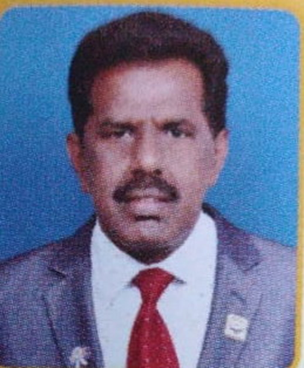****.*

***Lion M. Siddegowda – President. Educationist.*** *Has served more than 10 years as the President and Secretary, Lions Education Society, Nanjangud, Mysuru*

***Photo***

***Sri. Rajanna****, Retd, Forest Officer…..* ***Philanthropist***

***Photo***

***Sri. Narayanappa****, Social Activist &* ***Philanthropist***

***Photo***

***Er. Prakash****, Retd…. &* ***Philanthropist***

***Photo***

***Sri. Byrelinge Gowda****………. &* ***Philanthropist***

***Photo***

***Sri. Yogeesh****, LIC of India &* ***Philanthropist***

***Photo***

***Mrs.******J.******Josy Vinitha****,* ***Educationist***

***Photo***

***Ms.******Shruthishree******M.K.,******Educationis***

***Pioneers***

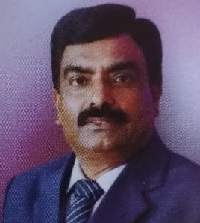

***Dr. Giniswamy*** *MSc, MPhil, PhD* ***– Secretary & Principal.*** *Superannuated Professor of Mathematics. Has a vast experience of more than 30 years in teaching PUC, BSc, MSc and Competitive Exams like CET, NEET & JEE etc. Has successfully guided PhD scholars.*

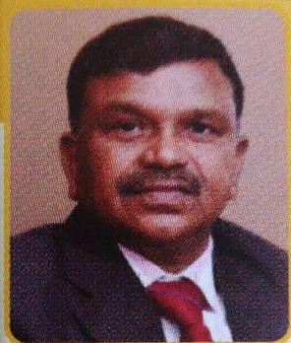

***Dr. M. H. Kondarasaiah*** *MSc, PhD* ***– Vice President & Academic Administrator.*** *Superannuated Principal & Professor of Chemistry, Maharani’s Science College for Women, Mysuru. Has a vast experience of more than 35 years of teaching PUC, BSc and Competitive exams like CET, NEET, & JEE etc.*

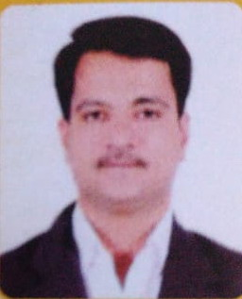***Dr. Mantelingu .K*** *MSc, PhD –* ***Vice President & Academic Coordinator.*** *Assistant Professor of Chemistry, University of Mysore. Sir C.V. Raman Young Scientist awardee (2015), Government of Karnataka. Merck Millipore India Innovation Awardee (2012). Has a vast experience of more than 15 years in teaching PUC, MSc & Competitive Exams like CET, NEET, & JEE etc. Has successfully guided 10 PhD scholars.*

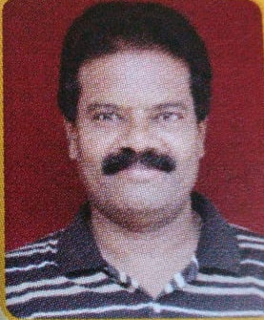***Prof. A. Thomas Gunaseelan*** *MSc, MPhil, PGDCA, (PhD) –* ***Joint Secretary & Career Guidance Coordinator.*** *Associate Professor of Physics. Has a rich experience of 30 years in teaching PUC, BSc and Competitive Exams like CET, NEET & JEE etc.*

***Patrons & Pillars***

***Dr. Jerald Pinto*** *MSc, PhD (Physics),**Milagres College, Udupi. Has an expertise in coaching students for competitive exams like CET, NEET & JEE etc., with more than 30 years of experience.*

***Dr. Victor Williams*** *MSc, PhD (Physics), St. Joseph’s (Autonomous) College, Tiruchirapalli, Tamilnadu. Has an expertise in coaching students for competitive exams like CET, NEET & JEE etc., with more than 30 years of experience.*

***Dr. John Shera*** *MSc, PhD (Mathematics), St. Aloysius College, Mangaluru.*

***Dr. T. Naveen Kumar*** *MSc, PhD (Chemistry), Alliance College of Engineering & Design, Alliance University, Bengaluru.*

***Dr. C. S. Ramesh*** *BE, ME, PhD (IIT, Madras), Dean, Research & Innovations, Presidency University, Bengaluru.*

